Pozyx – Tutorial 1: Ready To Range

Setup Notes

Reference:

<https://www.pozyx.io/Documentation/Tutorials/ready_to_range/Python>

Step 1:

Download all files, libraries, etc…refer to: https://www.pozyx.io/Documentation/Tutorials/getting_started/Python

Note: user must also manually install “requests” module (not described in above documentation)

Go to command prompt and enter:

C:\> pip install requests

Step 2:

Connect an anchor to PC (local machine) via USB cable connection

Eg: 0x675a

Step 3:

Connect a tag to remote power source (ie. Battery or Powerpoint)

NOTE: this tutorial only utilises 1 x tag and 1 x anchor

Step 4:

To identify Pozyx Tag / Anchor IDs, run python script:

C:\Projects\Pozyx\PythonFiles\Pozyx-Python-library-master\useful\basic_troubleshooting.py

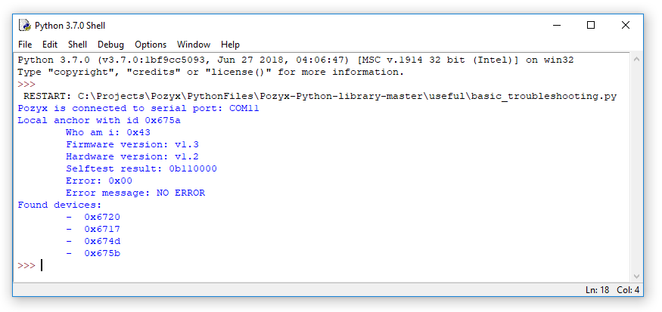

Figure 1: Tag ID information

Notes: Tag id is 0x6720 (connected remotely)

Anchor id 0x675a (connected to PC via serial port COM11)

Anchor id 0x6717 (connected remotely)

Anchor id 0x674d (connected remotely)

Anchor id 0x675b (connected remotely)

Step 5:

Run Python script:

C:\Projects\Pozyx\PythonFiles\Pozyx-Python-library-master\tutorials\ready_to_range.py

Notes: Code parameters that may need to be changed to suit user setup

* “remote_id”:
  + remote anchor id (eg. 0x674d in Figure 1)
  + set to *False* unless you want to range between tag and a remote anchor
* “destination_id”
  + tag id (eg. 0x6720 in Figure 1)
* range_step_mm =
  + enter an integer value for desired distance (in mm) between devices to trigger LEDs
  + eg. range_step_mm = 20 [20mm distance to trigger LEDs]
  + 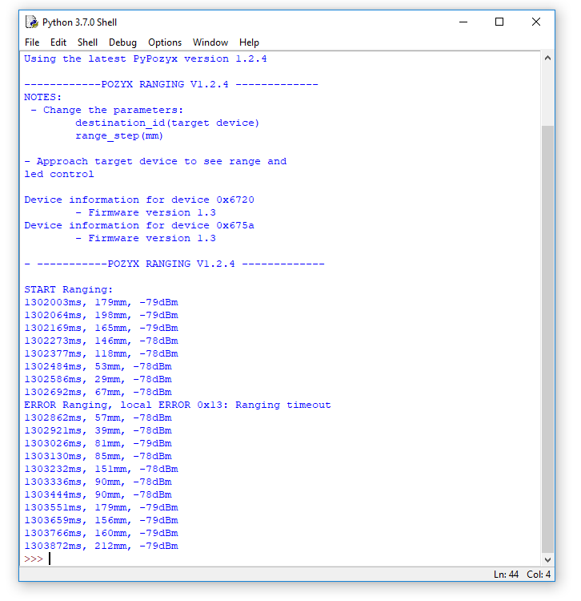

Figure 2: Range output after running “ready_to_range.py”